Chapter 7, Problem 53.

Determine the inductor current i(t) for both t < 0 and t > 0 for each of the circuits in Fig. 7.119.

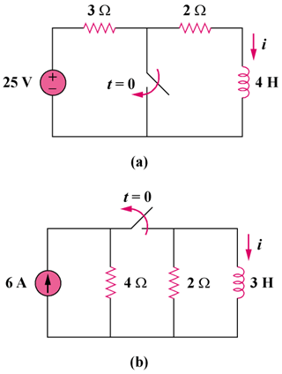

Figure 7.119
For Prob. 7.53.

